Question 1 : Draw an ER diagram in STARUML ?

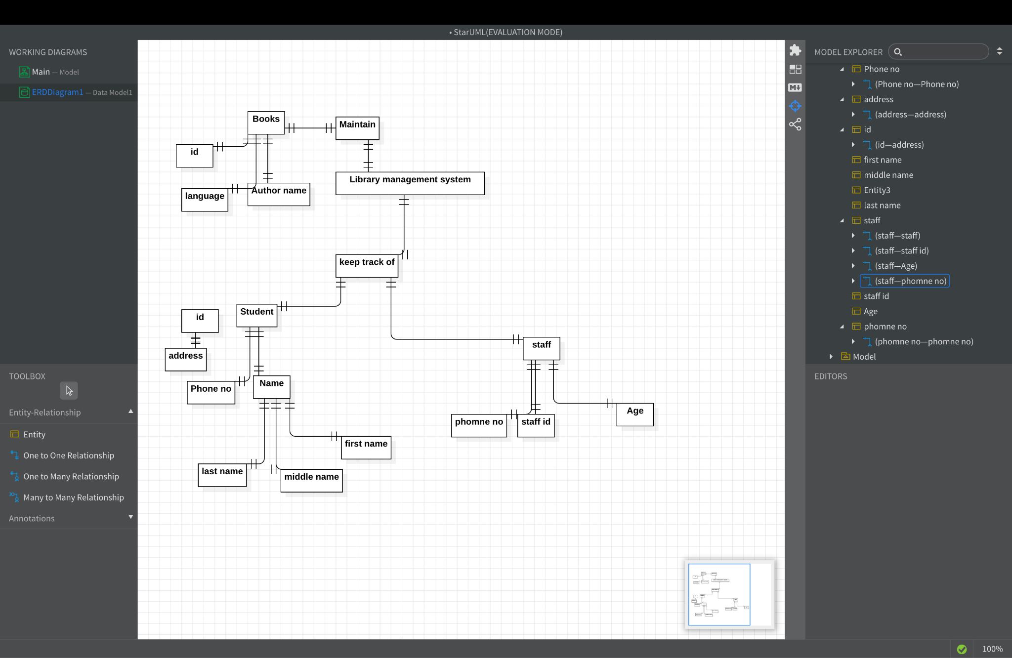

Question 2 : Draw a ER diagram In ms word with shapes ??

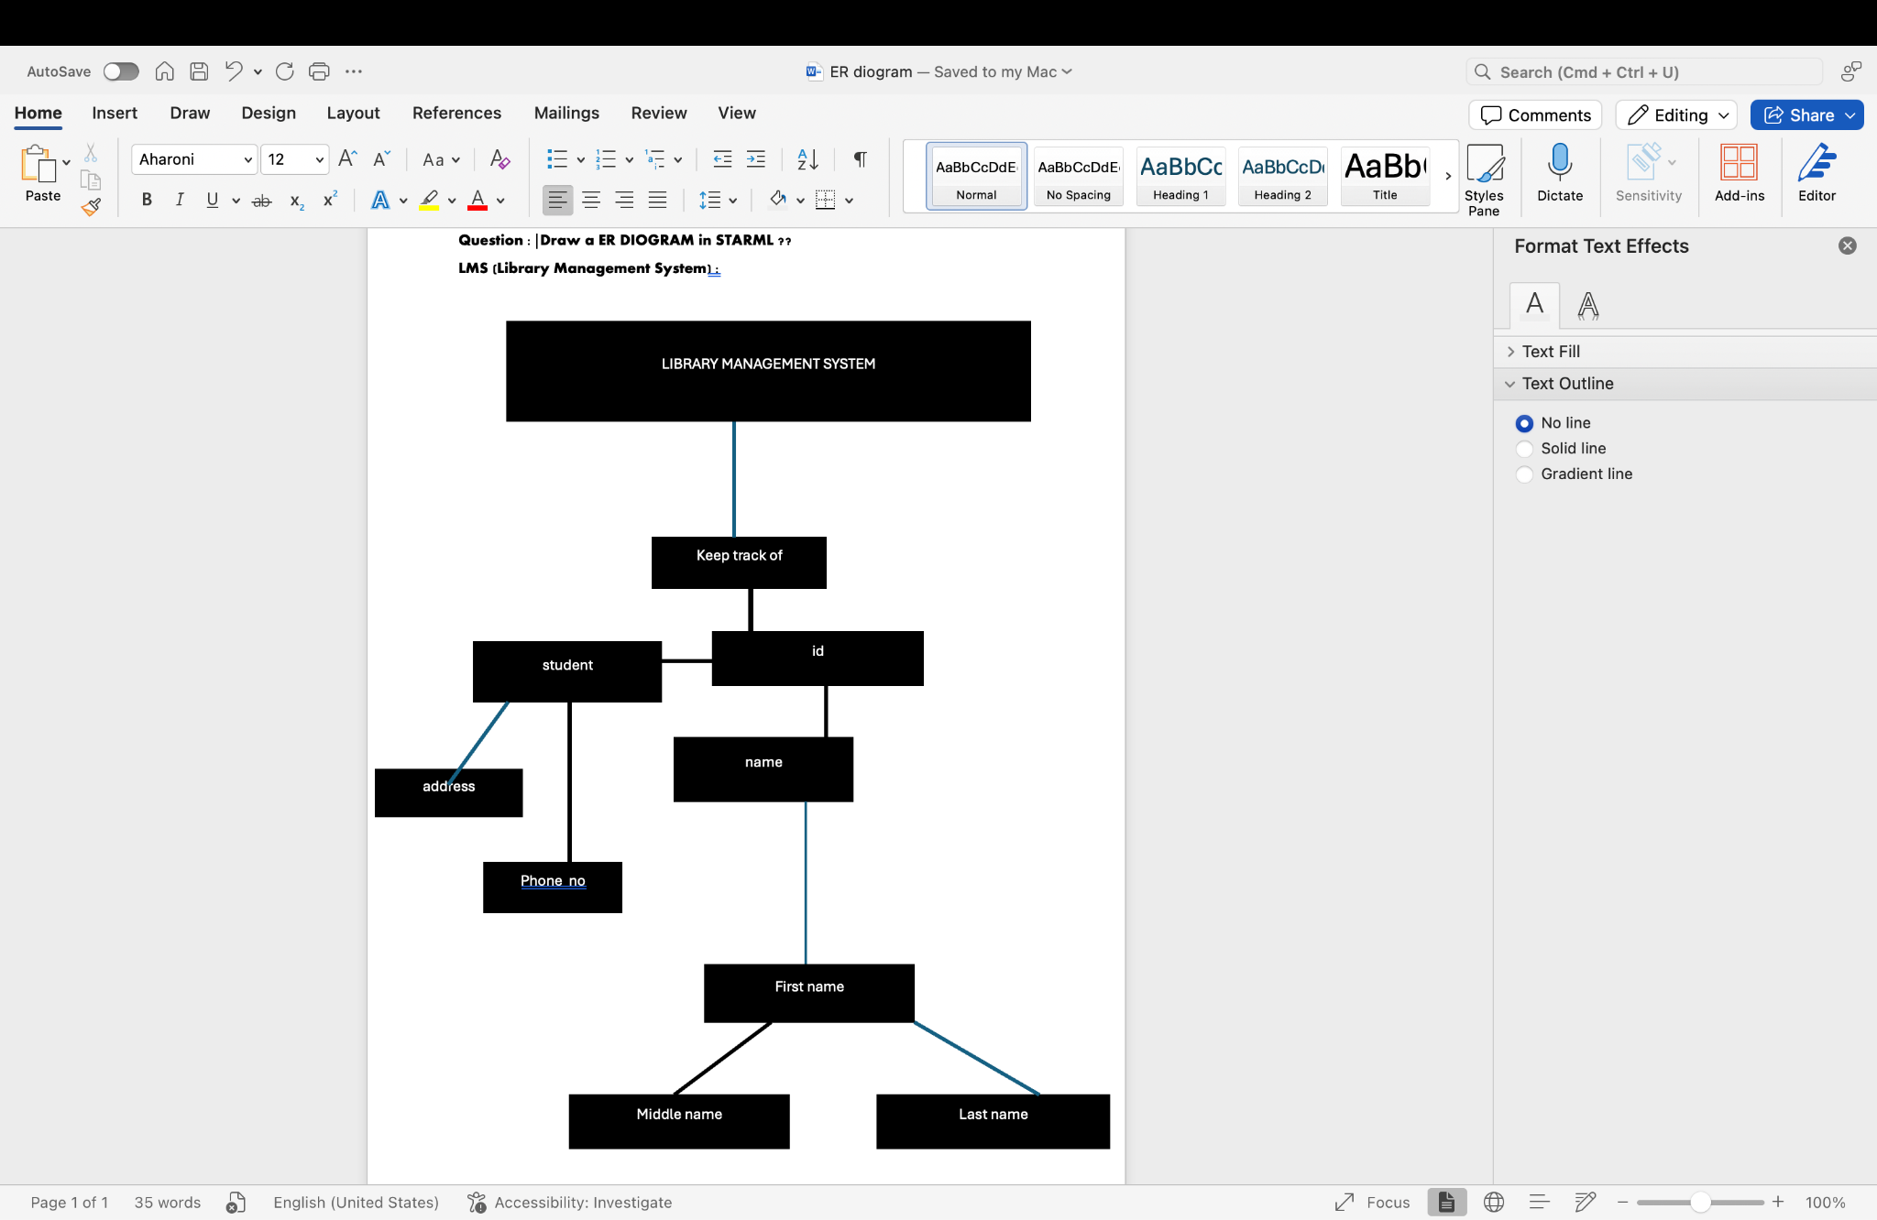

Question 3 : Requirement of System er diagram ??

### **1. Entities for LMS ERD**

These are the main objects or concepts within the LMS system.

#### **1.1 User**

* **Definition**: A person who interacts with the LMS (e.g., student, instructor, administrator).
* **Attributes**:
  + UserID (Primary Key)
  + FirstName
  + LastName
  + Email
  + Role (Student, Instructor, Admin)
  + Password
  + DateJoined
  + etc.
* **Relationships**:
  + A user may enroll in many courses.
  + A user may have many assessments, assignments, and grades.

#### **Course**

* **Definition: A course offered by an institution or instructor.**
* **Attributes:**
  + **CourseID (Primary Key)**
  + **Title**
  + **Description**
  + **StartDate**
  + **EndDate**
  + **InstructorID (Foreign Key referencing User)**
* **Relationships:**
  + **A course may have many students enrolled.**
  + **A course has one instructor.**
  + **A course may have many assignments and assessments.**

#### **Enrollment**

* **Definition: The act of a student registering for a course.**
* **Attributes:**
  + **EnrollmentID (Primary Key)**
  + **UserID (Foreign Key referencing User)**
  + **CourseID (Foreign Key referencing Course)**
  + **EnrollmentDate**
* **Relationships:**
  + **A student can enroll in many courses.**
  + **A course can have many students enrolled.**

#### **Grade**

* **Definition: The score or mark given to a student for a completed assignment or assessment.**
* **Attributes:**
  + **GradeID (Primary Key)**
  + **UserID (Foreign Key referencing User)**
  + **AssignmentID (Foreign Key referencing Assignment, optional)**
  + **AssessmentID (Foreign Key referencing Assessment, optional)**
  + **Score**
  + **DateAwarded**

#### **User-Enrollment-Course**

* **A User (Student) enrolls in one or many Courses through the Enrollment entity.**
* **A Course can have many Users (students) enrolled.**

#### **2.2 Course-Assignment**

* **A Course can have many Assignments.**
* **An Assignment is related to a specific Course.**

#### **2.3 Course-Assessment**

* **A Course can have many Assessments (quizzes, exams).**
* **An Assessment is linked to a specific Course.**

#### **2.4 Course-Instructor**

* **A Course has one Instructor (a User with the role of Instructor).**
* **An Instructor can teach many Courses.**

**:: Entities: User, Course, Enrollment, Assignment, Assessment, Grade, Discussion Forum, Post**

**:: Relationships:**

* **Users enroll in Courses.**
* **Courses have Assignments and Assessments.**
* **Users have Grades for Assignments/Assessments.**
* **Courses have Discussion Forums, and Users post in Forums.**
* **Instructors manage Courses and Assessments.**

### **User**

* **Definition: Represents individuals who interact with the LMS. This includes students, instructors, and administrators.**
* **Attributes:**
  + **UserID (Primary Key)**
  + **FirstName**
  + **LastName**
  + **Email**
  + **Role (Student, Instructor, Admin)**
  + **Password**
  + **DateJoined**
  + **ProfilePicture**
  + **PhoneNumber**

**Relationships:**

* **A User can enroll in many Courses.**
* **A User can create and participate in Assignments, Assessments, and Discussion Posts.**
* **. Course**
* **GRADE**
* **Enrollment**
* **User: Students, Instructors, and Admins.**
* **Course: A course offered by the institution.**
* **Assignment: Tasks students need to complete in a course.**
* **Assessment: Tests or exams to assess student performance.**
* **Grade: Scores awarded for completing assignments and assessments.**
* **Enrollment: Record of students registering for courses.**
* **Discussion Forum: A space for students and instructors to discuss course topics.**
* **Post: Individual messages within a forum.**
* **Material: Learning resources (documents, videos, etc.).**
* **Message: Communication between users (instructors, students).**
* **Certificate: Awarded to students upon course completion.**
* **Calendar/Event: Important dates and events related to courses and users.**